Viborg-Hurley Middle School

***"Empowering our students to succeed in a changing world."***

Expect Respect

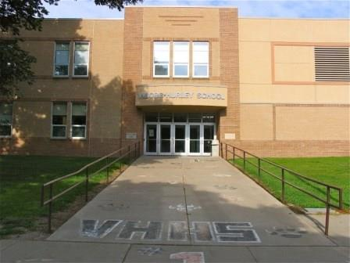

Parents/Guardians:

We need your help:

1. Helping provide support to each student
2. Helping provide the school support
3. Contact a school adult to report situations that are covert

*Who:

*What:

*When:

*Where:

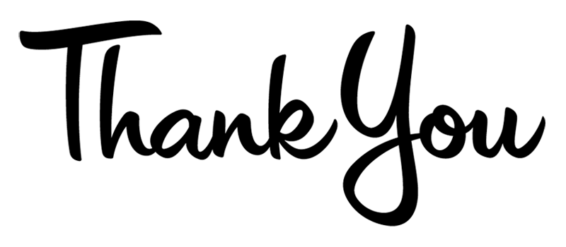

Students:

I pledge to keep the school safe by respecting others, respecting myself, and helping those who are being disrespected.

X________________________

What we have been doing

in the classroom:

*Education

*Role play scenarios

*Pledges

*Discussing current bullying

*Learning how to be a bystander who respects

*Creating Safety Plans

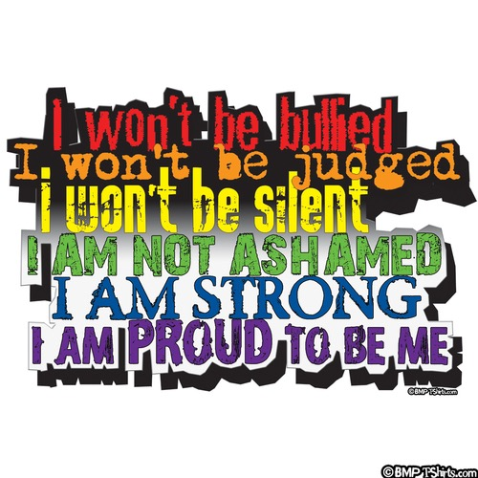



Bullying and harassment

include repeated :

~taunting

~rumor spreading

~humiliation

~name-calling

~exclusion

~physical aggression



The program:

*focuses on creating a positive school climate

*teaches students respect, safety, and responsibility

1. Stop Strategy: “Please Stop”

2. Stopping Strategy: “Okay, Cool.”

3. Bystander Strategy

4. Seeking Support Strategy

5. Providing Support Strategy