**Schmits Spark Starters**

**“Be the Spark”**

* **Be easy on yourself**
* **Celebrate simple things**
* **Dance like no one is watching**
* **Do math for funsies**
* **Do yoga**
* **Give a compliment**
* **Go for a bike ride**
* **Go outside**
* **Go running**
* **Have a mindful minute**
* **Help others**
* **Hug another person**
* **Journal**
* **Keep a positive attitude**
* **Laugh until you cry**
* **Laugh with others**
* **Leave our stress behind**
* **Listen to music**
* **Make art**
* **Play a sport**
* **Play outside**
* **Pretend you know to juggle random objects/be silly**
* **Read**
* **Relax**
* **Show appreciation**
* **Sing**
* **Sleep**
* **Take a break**
* **Take deep breaths**
* **Take some me time**
* **Talk to someone**
* **Treat yo’self**
* **Try something new**
* **Use humor**
* **You do you**

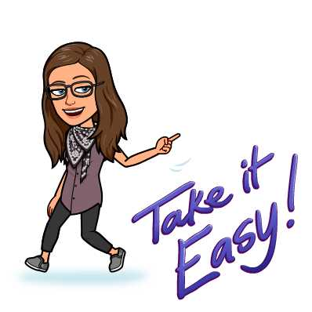

**Be easy on yourself**



**Celebrate simple things**



**Dance like no one is watching**

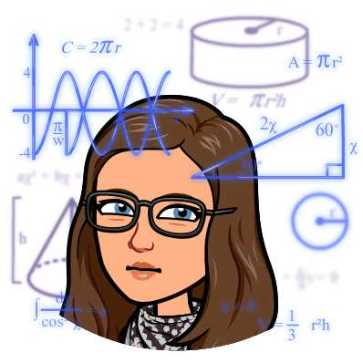

**Do math for funsies**

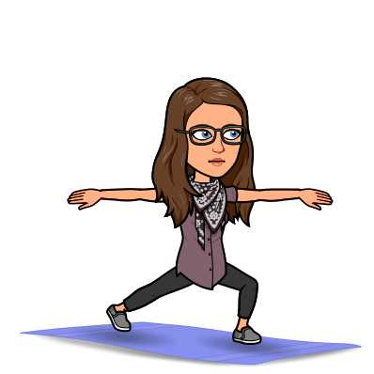

**Do yoga**



**Give a compliment**

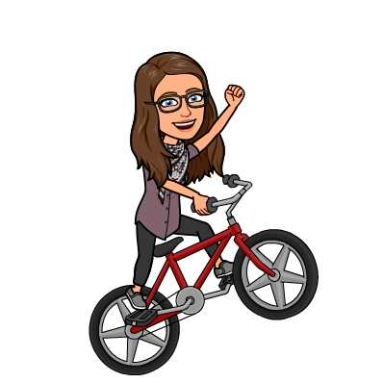

**Go for a bike ride**



**Go outside**

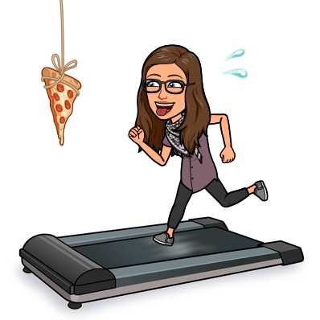

**Go running**

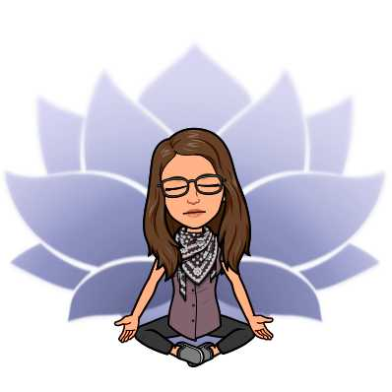

**Have a mindful minute**

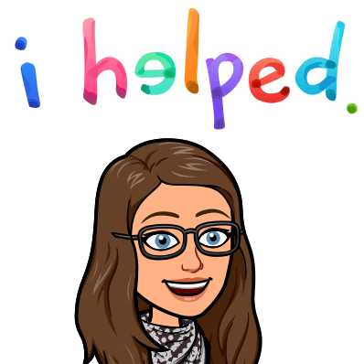

**Help others**



**Hug another person**



**Journal**



**Keep a positive attitude**



**Laugh until you cry**



**Laugh with others**

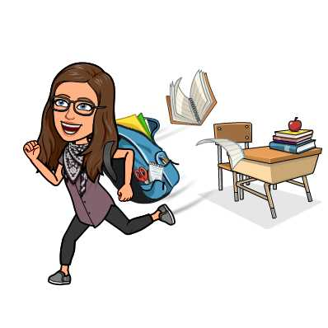

**Leave our stress behind**



**Listen to music**

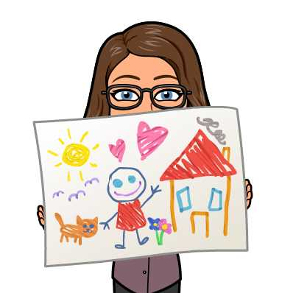

**Make art**



**Play a sport**



**Play outside**

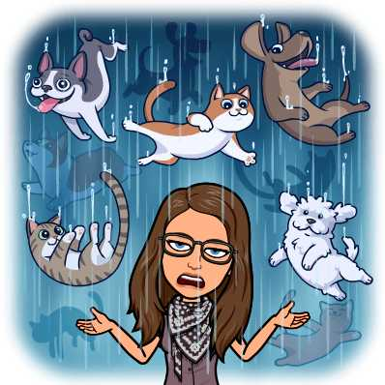

**Pretend you know to juggle random objects/Be silly**



**Read**



**Relax**



**Show appreciation**



**Sing**



**Sleep**



**Take a break**

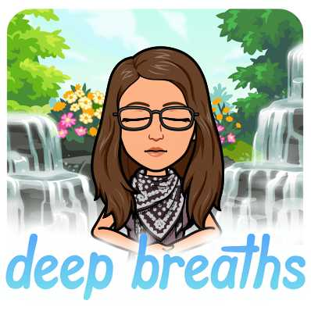

**Take deep breaths**

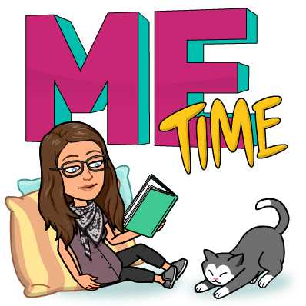

**Take some me time**

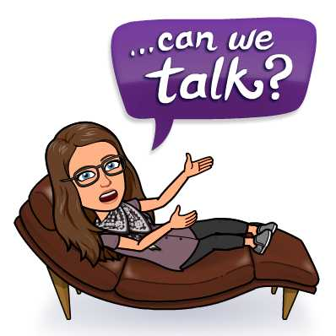

**Talk to someone**

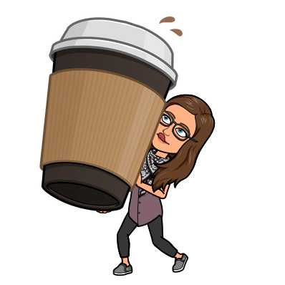

**Treat yo’self**



**Try something new**

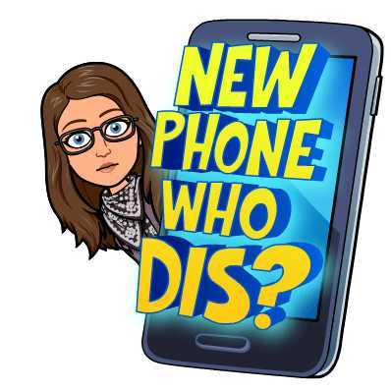

**Use humor**

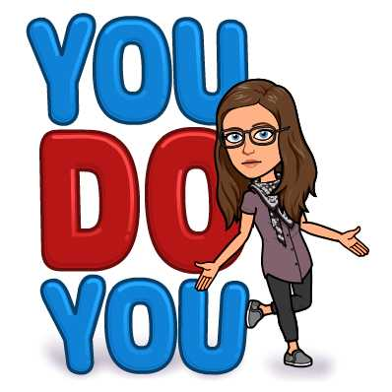

**You do you**